Final Project
Database Creation:
Creation of a Database Encompassing a
Students’ Performance and Their Classes

CPD123
Justin Horning
05/06/2025

CONTENTS:
SECTION I (Logical Database Design)
Title and Scenario
Entity-Relationship Diagram (ERD)
SECTION II (Physical Database Implementation)
CREATE DATABASE: JHORNING_STUDENTDB
CREATE TABLES and Screenshots:
- STUDENT + PK Constraint
- PROFESSORS + PK Constraint
- COURSES + PK & FK Constraints
- PERFORMANCE + PK & FK Constraints
INSERT, UPDATE, and ALTER data in/into Tables and Screenshots:
- STUDENT
- PROFESSORS + CHECK Constraint
- COURSES
- PERFORMANCE + CHECK Constraint
QUERIES and Screenshots:
- Aggregate Function: COUNT
- Aggregate Function: COUNT; with GROUP BY and HAVING clauses
- JOIN 2 Tables(COURSES, PROFESSORS) with a WHERE clause
- JOIN 2 Tables(COURSES, PROFESSORS) with an INNER JOIN
- JOIN 3 Tables(STUDENT, COURSES, PERFORMANCE) with a WHERE clause

SECTION III (Final Report Summary)
Final Report: Summary of Issues and Solutions

SECTION I (Logical Database Design)
Scenario: Creation of a Database Encompassing a Student’s Performance and Their Classes by Justin Horning
The following database contains data tracking a student’s performance in his/her courses, along with the professor who teaches that course. The first part of the database you will see is the Entity-Relationship Diagram (ERD) that contains the four tables involved in this database, their relationships to each other, constraints, field names(columns), and their specific data types. The four tables are STUDENT, PROFESSORS, COURSES, and PERFORMANCE.
Succeeding the ERD, you will come across the SQL code that is responsible for the creation of the database, along with a screenshot of the code and its results. After which, you will see the SQL code that is responsible for creating the four tables mentioned above, as well as the screenshots and results of the code. Following the creation of the tables is the SQL code that will insert data into each of the four tables and a screenshot of the data-filled table. Next will be the SQL code for the 5 (five) queries, 2 (two) aggregate functions + 3 (three) joins, the results and screenshots of the SQL code, and an explanation of what each query is executing. Lastly, the end of the project will include a report on the issues that were encountered and the solution of these issues.
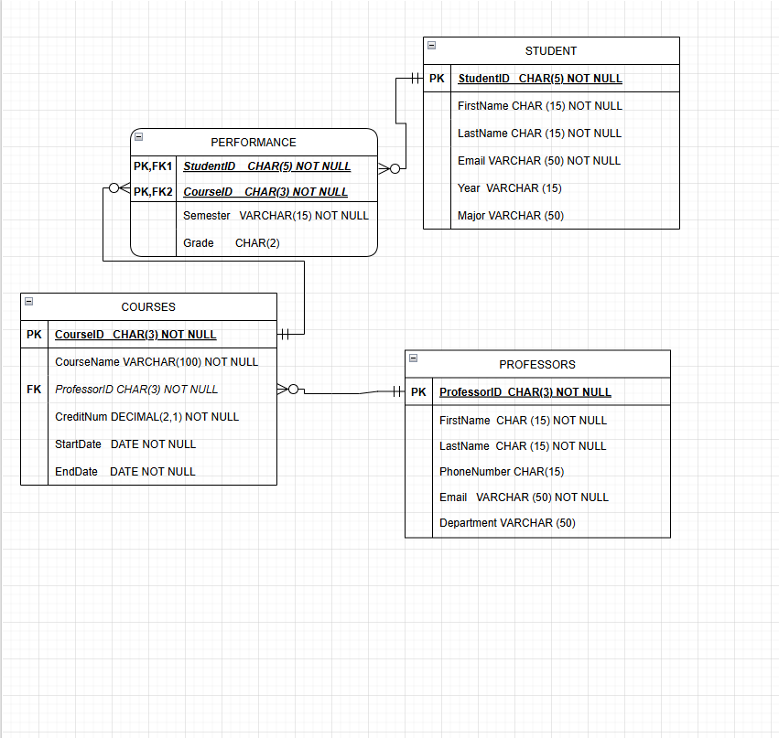
SECTION II (Physical Database Implementation)
CREATE Database
CREATE DATABASE JHORNING_STUDENTDB;
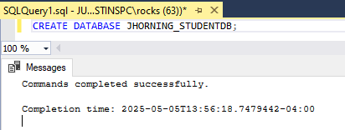
This sql query creates the database JHORNING_StudentDB.
CREATE Tables
STUDENT Table Query
CREATE TABLE STUDENT
(StudentID CHAR(5) PRIMARY KEY NOT NULL,
LastName CHAR(15) NOT NULL,
FirstName CHAR(15) NOT NULL,
Email VARCHAR(50) NOT NULL,
Year VARCHAR(15),
Major VARCHAR(50)
);
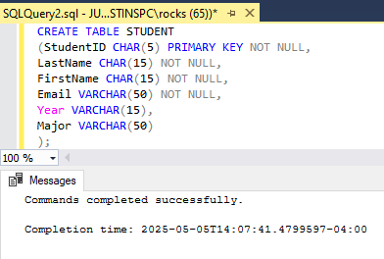
This sql query creates the STUDENT table and specifies the fields, data types, and constraints.
STUDENT Table Structure
This sql query shows the specified procedures of each field in the STUDENT Table.
EXEC sp_columns STUDENT;
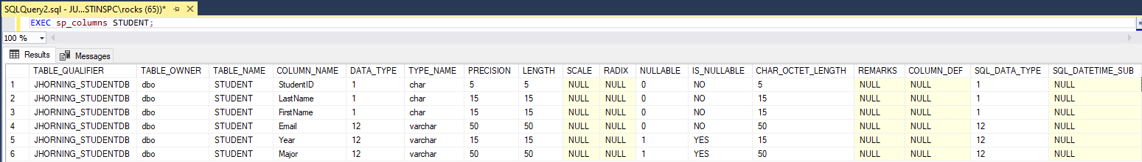

PROFESSORS Table Query
This sql query shows the specified procedures of each field in the STUDENT Table.
CREATE TABLE PROFESSORS
(ProfessorID CHAR(3) PRIMARY KEY NOT NULL,
LastName CHAR(15) NOT NULL,
FirstName CHAR(15) NOT NULL,
Email VARCHAR(50) NOT NULL,
PhoneNumber CHAR(15),
Department VARCHAR(50)
);
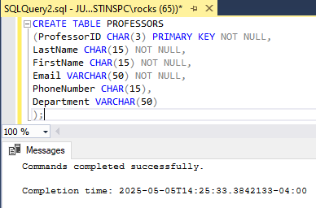
This sql query creates the Professors table and specifies the fields, data types, and constraints.

PROFESSORS Table Structure
This sql query shows the specified procedures of each field in the professors Table.
EXEC sp_columns PROFESSORS;
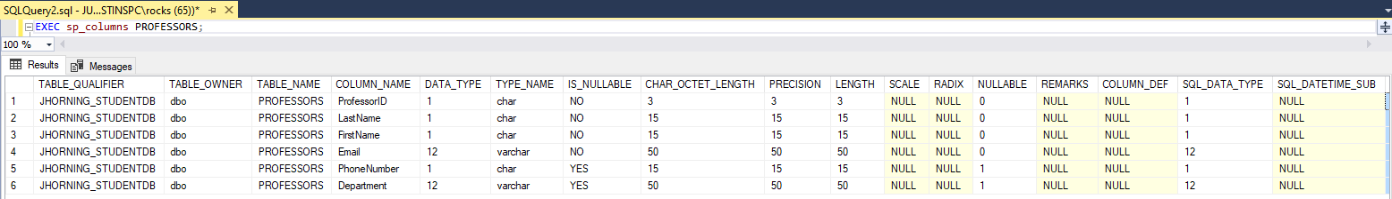

COURSES Table Query
CREATE TABLE COURSES
(CourseID CHAR(3) PRIMARY KEY NOT NULL,
CourseName VARCHAR(100) NOT NULL,
ProfessorID CHAR(3) NOT NULL,
CreditNum DECIMAL(2,1) NOT NULL,
StartDate DATE NOT NULL,
This sql query creates the COURSES table and specifies the fields, data types, and constraints.
EndDate DATE NOT NULL,
CONSTRAINT FK_PROFESSORID FOREIGN KEY (ProfessorID) REFERENCES PROFESSORS (ProfessorID)
);
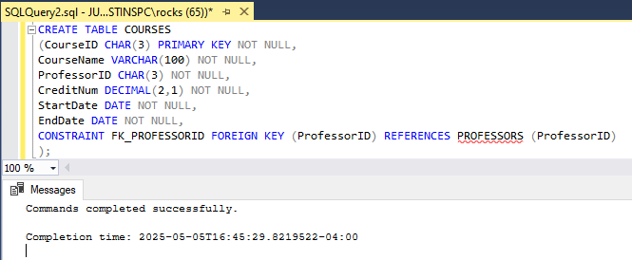

COURSES Table Structure
This sql query shows the specified procedures of each field in the COURSES Table.
EXEC sp_columns COURSES;
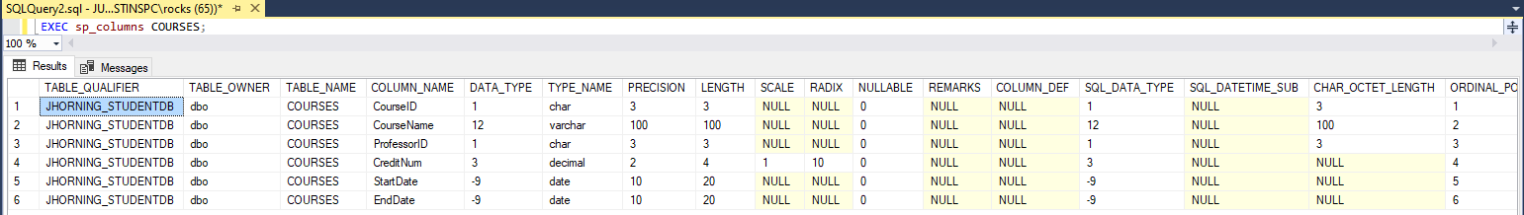

PERFORMANCE Table Query
CREATE TABLE PERFORMANCE
(StudentID CHAR(5) NOT NULL,
CourseID CHAR(3) NOT NULL,
Semester VARCHAR(15) NOT NULL,
GRADE CHAR(2),
CONSTRAINT PK_PERFORMANCE PRIMARY KEY (StudentID, CourseID),
CONSTRAINT FK1_PERFORMANCE FOREIGN KEY (StudentID) REFERENCES STUDENT(StudentID),
CONSTRAINT FK2_PERFORMANCE FOREIGN KEY (CourseID) REFERENCES COURSES(CourseID)
);
This sql query creates the PERFORMANCE table and specifies the fields, data types, and constraints.
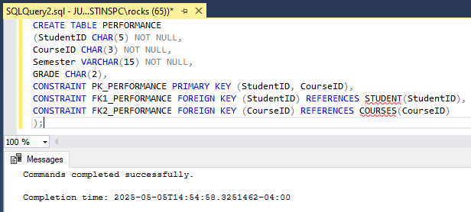

PERFORMANCE Table Structure
This sql query shows the specified procedures of each field in the PERFORMANCE Table.
EXEC sp_columns PERFORMANCE;
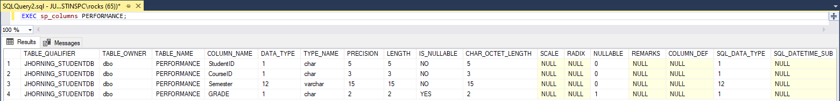

INSERT, UPDATE, and ALTER
INSERT INTO STUDENT
VALUES ( '00001', 'Horning', 'Justin', 'jhorning@starkstate.net', 'Freshman', 'Web Design and Development');
INSERT INTO STUDENT
VALUES ( '00002', 'Cobb', 'Keaton', 'kcobb@starkstate.net', 'Freshman', 'Education');
INSERT INTO STUDENT (StudentID, LastName, FirstName, Email, Major)
VALUES ( '00003', 'Ray', 'Camila', 'cray@starkstate.net', 'Dental Hygiene');
INSERT INTO STUDENT (StudentID, LastName, FirstName, Email, Year)
VALUES ( '00004', 'Hurst', 'Jett', 'jhurst@starkstate.net', 'Sophomore');
INSERT INTO STUDENT
VALUES ( '00005', 'Boyd', 'Sydnee', 'sboyd@starkstate.net', 'Senior', 'Music Theory and Composition');
INSERT INTO STUDENT (StudentID, LastName, FirstName, Email, Year)
VALUES ( '00006', 'Morrison', 'Dale', 'dmorrison@starkstate.net', 'Junior');

SELECT *
FROM STUDENT;
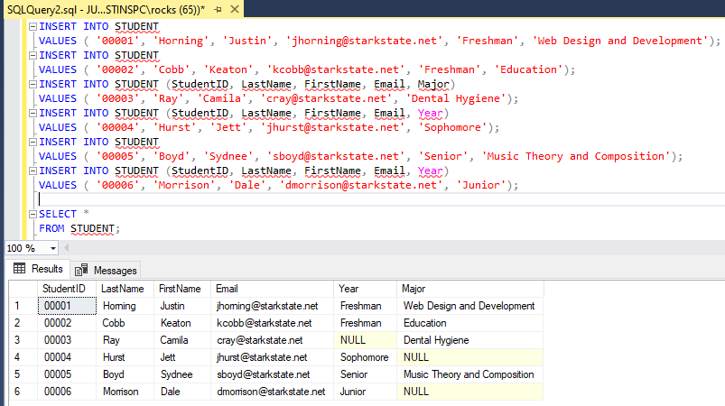
This sql query INSERTS DATA INto the student table. it then selects all the fields to show they were added.

INSERT INTO PROFESSORS
VALUES ( '001', 'Hooper', 'Azul', 'ahooper@starkstate.edu', '330-480-4900', 'Arts');
INSERT INTO PROFESSORS
VALUES ( '002', 'Ayers', 'Carmen', 'cayers@starkstate.edu', '330-480-4910', 'Education');
INSERT INTO PROFESSORS (ProfessorID, LastName, FirstName, Email, Department)
VALUES ( '003', 'Knox', 'Abbey', 'aknox@starkstate.edu', 'Health Professions');
INSERT INTO PROFESSORS
VALUES ( '004', 'Dillon', 'Jessie', 'jdillon@starkstate.edu', '330-480-4920', 'Arts');
INSERT INTO PROFESSORS
VALUES ( '005', 'May', 'Jakob', 'jmay@starkstate.edu', '330-480-4910', 'Arts');
INSERT INTO PROFESSORS (ProfessorID, LastName, FirstName, Email, Department)
VALUES ( '006', 'Stewart', 'Ellie', 'estewart@starkstate.edu', 'Science, Technology, and Math');

SELECT *
This sql query INSERTS DATA INto the PROFESSORS table. it then selects all the fields to show they were added.
FROM PROFESSORS;

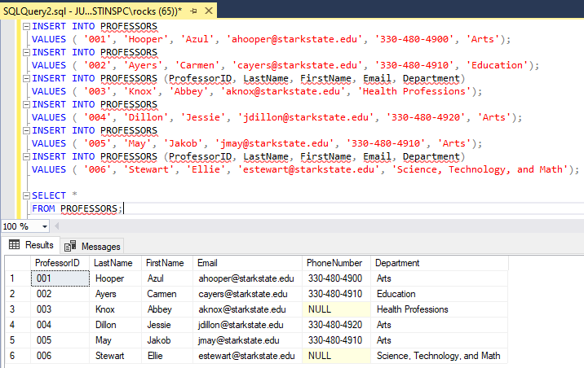ALTER TABLE PROFESSORS
ADD CHECK (PhoneNumber LIKE ('[0-9][0-9][0-9]-[0-9][0-9][0-9]-[0-9][0-9][0-9][0-9]'));
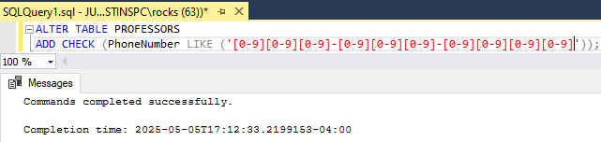
This sql query places a check constraint on the table and will only allow a phone number in ###-###-#### format.
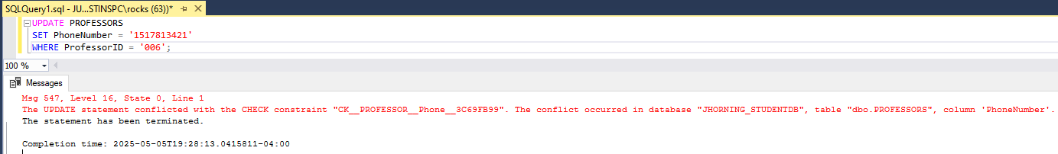
Produces an error because the format for phonenumber is wrong.

INSERT INTO COURSES
VALUES ( '001', 'Graphic Design', '001', 3, '01-13-2025', '05-11-2025');
INSERT INTO COURSES
VALUES ( '002', 'Early Childhood Education', '002', 3, '01-13-2025', '05-11-2025');
INSERT INTO COURSES
VALUES ( '003', 'Dental Hygiene', '003', 3, '01-13-2025', '05-11-2025');
INSERT INTO COURSES
VALUES ( '004', 'Music Theory and Composition', '004', 3, '01-13-2025', '05-11-2025');
INSERT INTO COURSES
VALUES ( '005', 'Web Page and Digital Design', '005', 3, '01-13-2025', '05-11-2025');
INSERT INTO COURSES
VALUES ( '006', 'Computer Programming', '006', 3, '01-13-2025', '05-11-2025');

SELECT *
FROM COURSES;

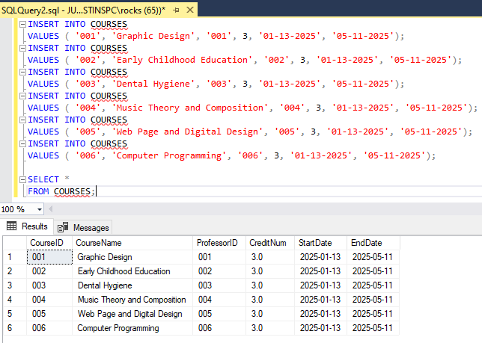
This sql query INSERTS DATA INto the Courses table. it then selects all the fields to show they were added.
INSERT INTO PERFORMANCE
VALUES ( '00001', '005', 'Spring', 'A');
INSERT INTO PERFORMANCE
VALUES ( '00002', '002', 'Spring', 'A-');
INSERT INTO PERFORMANCE
VALUES ( '00003', '003', 'Spring', 'B+');
INSERT INTO PERFORMANCE
VALUES ( '00004', '006', 'Spring', 'C');
INSERT INTO PERFORMANCE
VALUES ( '00005', '004', 'Spring', 'A+');
INSERT INTO PERFORMANCE
VALUES ( '00006', '001', 'Spring', 'D-');

SELECT *
FROM PERFORMANCE;
This sql query INSERTS DATA INto the PERFORMANCE table. it then selects all the fields to show they were added.
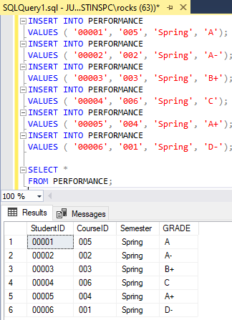

ALTER TABLE PERFORMANCE
ADD CHECK (Grade IN ('A+', 'A', 'A-', 'B+', 'B', 'B-', 'C+', 'C', 'C-', 'D+', 'D', 'D-', 'F'));
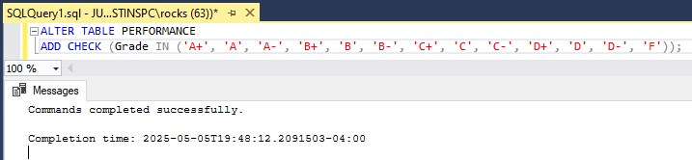
This sql query places a check constraint on the table and will only allow a Grade in within the format provided.
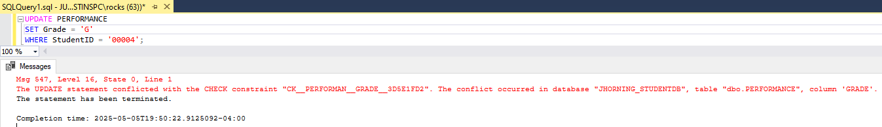
Produces an error because the format for Grade is wrong.

Queries

SELECT COUNT (LastName) AS NUMBER_OF_PROFESSORS
FROM PROFESSORS;
This sql query counts the number of rows in the professor table while providing the resulting column with a name
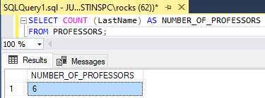

SELECT GRADE, COUNT (*) AS STUDENTS_WITH_A
FROM PERFORMANCE
This sql query counts the number of rows in the professor table while providing the resulting column with a name.
GROUP BY GRADE
HAVING GRADE = ('A+', 'A', 'A-');
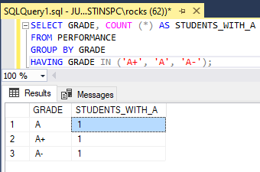
This sql query counts the number of rows in the PERFORMANCE table while providing the resulting column with a name and how many students have an A+, a, or A-.

SELECT CourseName AS 'Name of Course', FirstName, LastName
FROM COURSES AS C, PROFESSORS AS P
WHERE P.ProfessorID = C.ProfessorID;
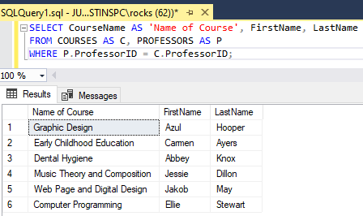
This sql query selects specific fields from the courses and professor table using a where clause. requiring that the professor ids match in both tables for a result.

SELECT CourseName AS 'Name of Course', FirstName, LastName
FROM COURSES AS C
INNER JOIN PROFESSORS AS P
ON P.ProfessorID = C.ProfessorID
ORDER BY CourseName ASC;
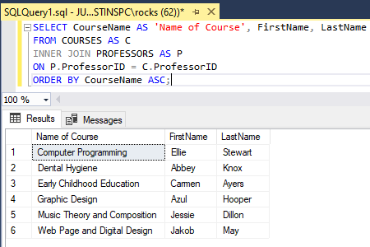
This sql query selects specific fields from the courses and professor table using an inner join. requiring that the professor ids match in both tables for a result. and ordering the course names in alphabetical order.

SELECT FirstName, LastName, CourseName AS 'Name of Course'
FROM STUDENT AS S, COURSES AS C, PERFORMANCE AS P
WHERE C.CourseID = P.CourseID AND
S.StudentID = P.StudentID;
This sql query selects specific fields from the Student, courses, and performance table using a where clause. requiring that the course ids match in both tables and student ids match in both tables for a result.
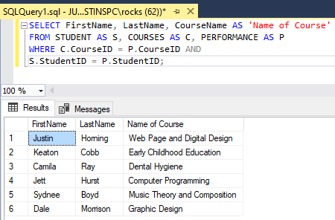

SECTION III (Final Report Summary)
Final Report: Summary of Issues and Solutions

The following list describes the issues that I encountered throughout the creation of this database and the solutions I found to solve those issues.

- Issue: Insertion of CreditNum data. After I created all of the tables I ran into the issue of my insert statement for CreditNum not taking the value of 3 (three). At the time, I did not remember that DECIMAL(1,1) would result in me not being able to provide a value over 0.9. I started to scan the book coming across the Figure 3-16 (page 70) in Chapter 3, where the table explains data types even further, more specifically the DECIMAL data type. I had to drop both the COURSES table and the PERFORMANCE table to correct my errors and then re-run the SQL scripts I had written in this document, changing to DECIMAL(2,1).
- Issue: Forgetting the length of the data type. First off, I want to say this is ENTIRELY my fault, as I came back to this at a different point in time. When I was inserting the StudentID data into the PERFORMANCE table I continued to write '001'. For reference, the length data type for StudentID in the STUDENT table is CHAR(5). You can see where this is going, I sat here for about 25 (twenty-five) minutes searching through the book trying to see if I was writing my INSERT statement wrong. I accidentally clicked my mouse wheel in and my pages scrolled up, seeing the STUDENT table again and realizing the EASIEST mistake I made. I then changed the StudentID data that I was inserting into the PERFORMANCE table to '00001' and not to my surprise, my issue was fixed.

To conclude the entire project, it puts into perspective the amount of time and work that goes into creating a good functioning database. Making sure that the database creator pays attention to detail *cough* me is extremely important when not just creating the tables, but also when inserting data into them. The skills I learned in this class helped to improve my SQL knowledge while also providing me with some hilarious memories to look back on. In the end, everything always takes time and mistakes are bound to happen. It’s just up to us to make sure we take the time to fix them and learn from them.
P.S.
Thank you “GeoGeek Yaeger” (I suck at Geography) for the support that you give to not just me, but all of the students in your class. I don’t honestly believe that I could have learned so much with a different professor. I would probably still be stuck in Data Modeling and Database Design lol. I hope that life is treating you well and I hope you have a fantastic summer!

